1. What is PySpark, and how does it work?

PySpark is the Python API for Apache Spark, an open-source distributed computing system designed for big data processing and analytics. PySpark allows you to write Spark applications using Python, making it easier for Python developers to work with large datasets across a cluster of machines.

Apache Spark Core:

Spark is written in Scala and runs on the Java Virtual Machine (JVM).

PySpark acts as a bridge between Python code and the Spark engine.

Python Driver Program:

You write Python code using PySpark.

This code creates a SparkContext or SparkSession to connect to a Spark cluster.

Communication via Py4J:

PySpark uses Py4J, a library that enables Python programs to dynamically access Java objects.

Your Python code communicates with the JVM-based Spark engine under the hood.

RDD and DataFrame APIs:

You can work with RDDs (Resilient Distributed Datasets) for low-level operations or use DataFrames for higher-level SQL-like operations.

DataFrames are more optimized and easier to use.

Distributed Processing:

Spark splits your data and code into tasks and distributes them across worker nodes in a cluster.

Workers perform computations in parallel, boosting performance for large datasets.

Lazy Evaluation:

PySpark builds a DAG (Directed Acyclic Graph) of transformations and only executes them when an action (like .collect(), .show(), .write()) is called.

✅ Key Features:

Parallel computing: Handles massive data volumes.

Scalability: Works on a local machine or a massive cluster.

Built-in support for SQL, ML, Streaming, Graphs via libraries like:

pyspark.sql

pyspark.ml

pyspark.streaming

pyspark.graphframes

2. Explain the architecture of PySpark.

1. Driver Program (Python)

Where your PySpark code runs.

Contains the SparkSession or SparkContext.

Converts operations into a DAG (Directed Acyclic Graph).

Sends tasks to the cluster manager.

2. PySpark API (Python Layer)

Provides classes like DataFrame, RDD, SparkSession, etc.

Uses Py4J to translate Python commands into JVM calls.

3. Py4J Gateway

A communication bridge between the Python process and the JVM process.

Converts Python commands into Java bytecode calls and vice versa.

4. Spark Driver (JVM)

The actual master node.

Handles:

Task scheduling

Job coordination

Fault tolerance

5. Cluster Manager

Manages resources across the cluster.

Allocates Executors to the Driver.

Types:

Standalone

YARN

Mesos

Kubernetes

6. Executors (on Worker Nodes)

Run the tasks sent by the driver.

Perform transformations and actions.

Store data in memory or disk (for caching/persistence)

3.What are the differences between RDD, DataFrame, and Dataset?  
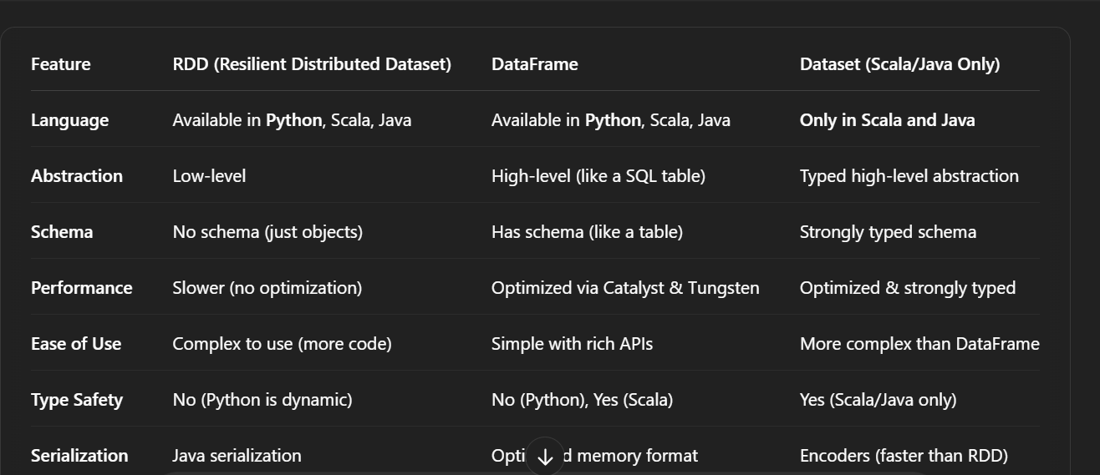

4. How does Spark handle fault tolerance?  
  
**1. RDD Lineage (Core to Fault Tolerance)**

* Spark keeps track of the **lineage** of an RDD — basically, a **record of all transformations** (like map, filter, join) that were used to create it. If part of an RDD is lost (e.g., due to node failure), **Spark can recompute it** from the original data using this lineage.
* All transformations in Spark are **lazy**. When you perform an action (like collect() or count()), Spark builds a **DAG (Directed Acyclic Graph)** of stages and tasks.If a task fails, Spark **knows exactly how to recompute** it using the DAG plan.
* If an **executor fails**, only the **lost tasks** are rescheduled on other nodes. Spark doesn't restart the entire job — only the failed parts are rerun, saving a lot of time.
* • For long lineage chains or iterative computations (like with ML algorithms), lineage can get expensive.Spark supports **checkpointing**, where it saves an RDD to **reliable storage (like HDFS)**.If a failure occurs, Spark **reads from the checkpoint** instead of recomputing from scratch

5. What are the different types of transformations in PySpark?

**Narrow Transformations**

* Data required to compute the records in a single partition **reside in a single partition** of the parent RDD/DataFrame.
* No **shuffling** of data between partitions.
* **Fast and efficient.**

**Wide Transformations**

* Data from **multiple partitions** are required to compute a single partition of the result.
* **Triggers a shuffle**, i.e., redistributing data across the cluster.
* **Slower and more expensive**, but necessary for some operations.

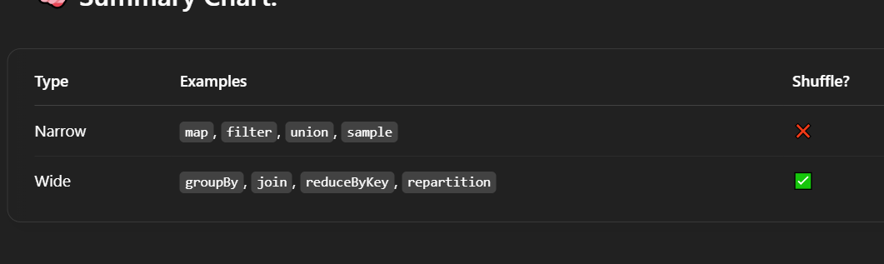  
  
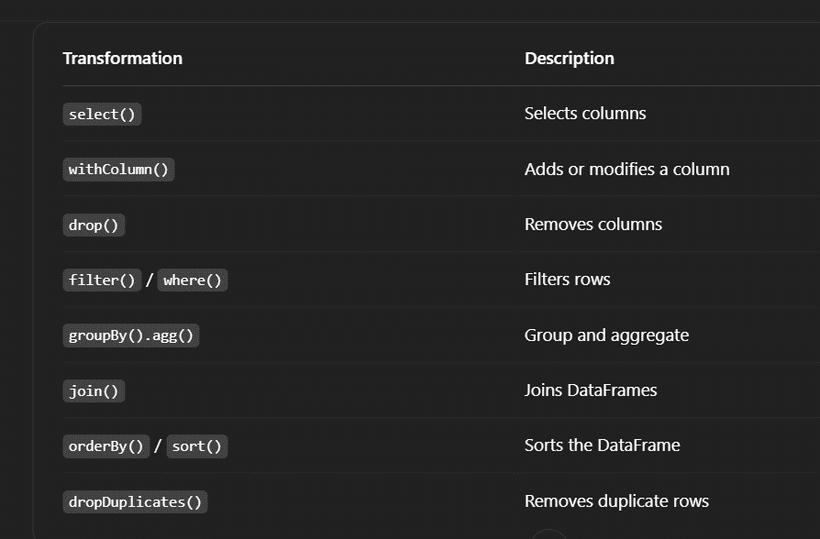

6. Explain the significance of the DAG (Directed Acyclic Graph) in Spark.  
  
A **Directed Acyclic Graph (DAG)** in Spark represents a **logical execution plan** of a Spark job. It’s a graph where:

* **Nodes** represent **RDDs/DataFrames** created at each transformation step.
* **Edges** represent the **dependencies** between them (i.e., how one RDD is derived from another).
* It is **directed** (has a clear flow of execution) and **acyclic** (no loops or cycles).

**1. Tracks Transformations**

Spark uses the DAG to **track all transformations** (like map, filter, join) in your program.

**2. Enables Lazy Evaluation**

Instead of executing each transformation immediately, Spark **builds a DAG** of operations. This:

* Delays execution until an action (collect(), save(), etc.) is triggered.
* Helps optimize the entire workflow.

**3. Optimizes Execution**

Before running the job, Spark’s **DAG Scheduler**:

* Splits the DAG into **stages** (based on narrow and wide transformations).
* Each stage is divided into **tasks** for parallel execution.
* Schedules tasks intelligently to **minimize data shuffling** and maximize locality.

**4. Supports Fault Tolerance**

If a task or node fails, Spark can **recompute lost data** using the DAG lineage, rather than restarting everything.

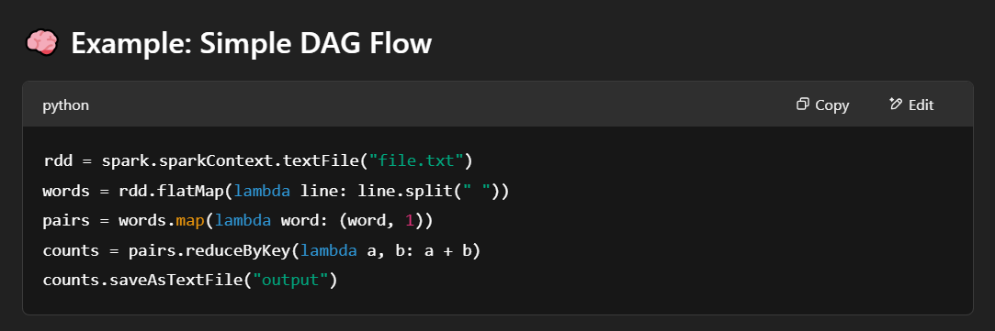

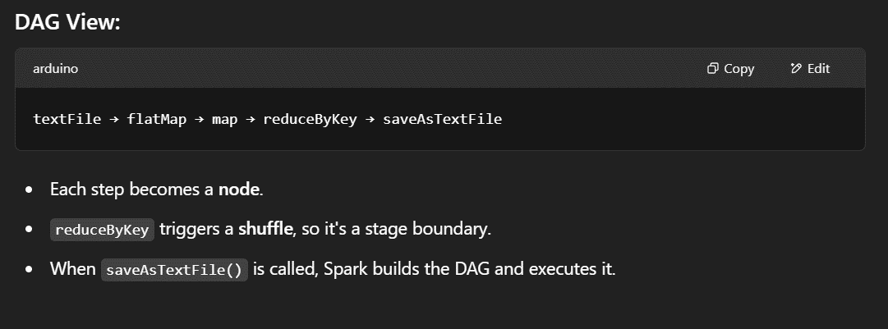

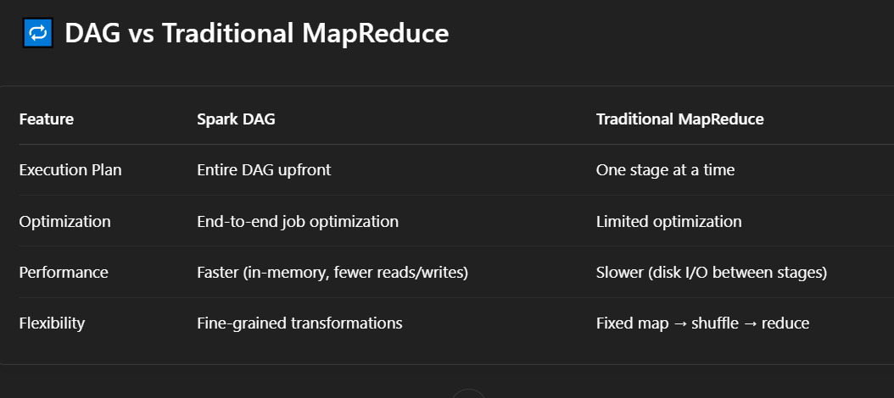

7. is the role of the driver and executor in PySpark?  
  
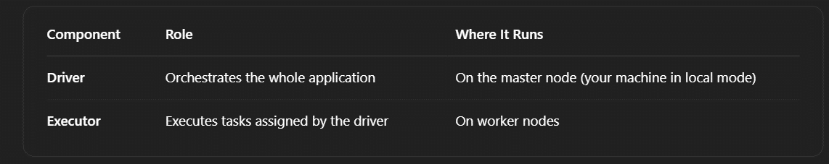

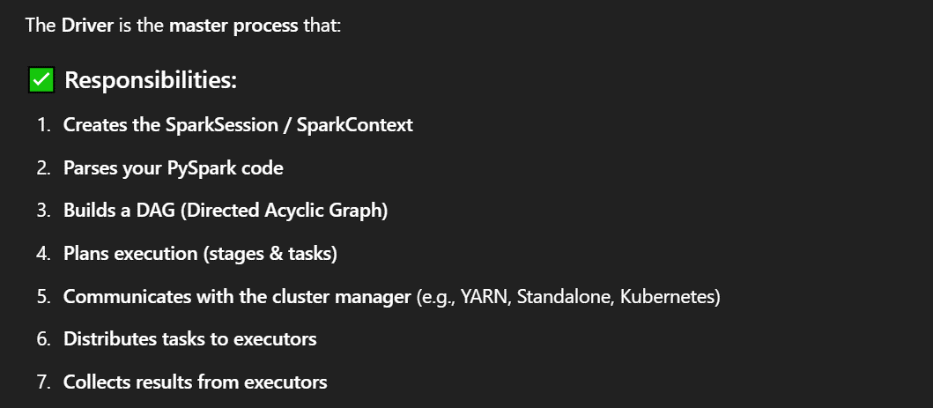

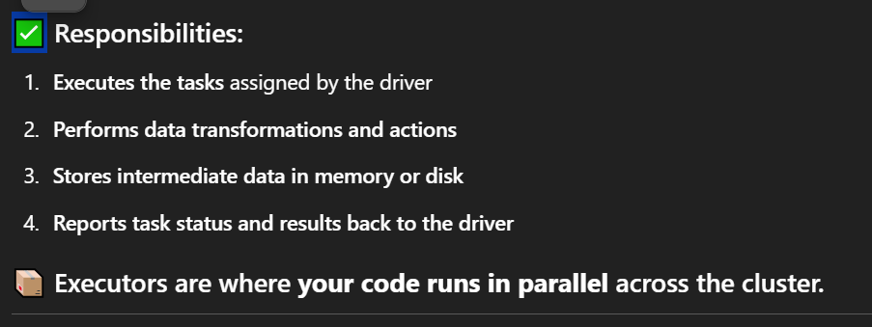

9. How does PySpark handle schema inference?

**1. Enabled by Default for Some Formats**

* For formats like **CSV** or **JSON**, you can enable schema inference with inferSchema=True.

When you enable inferSchema=True, Spark does this:

1. **Reads the header** (if header=True)
2. **Scans the first few rows** to sample data types
3. **Infers each column's data type**
4. Builds a StructType schema internally

Schema inference **requires reading a subset of the data** to guess types, which **adds overhead**.For large files, it can slow things down.

**Solution**: Define schema manually for better performance.

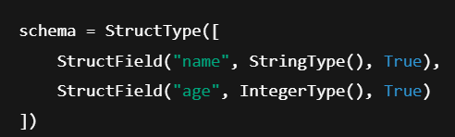

10.What are the different types of joins in PySpark?

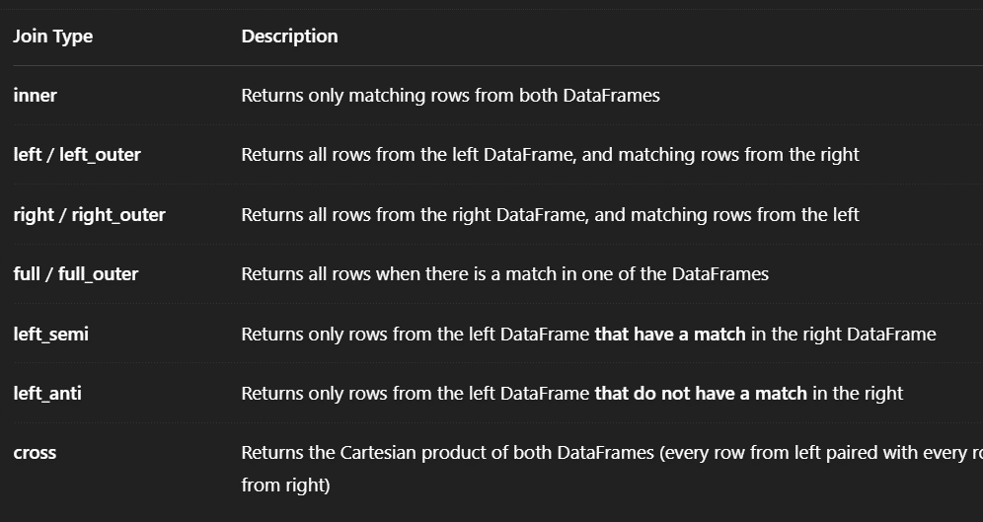

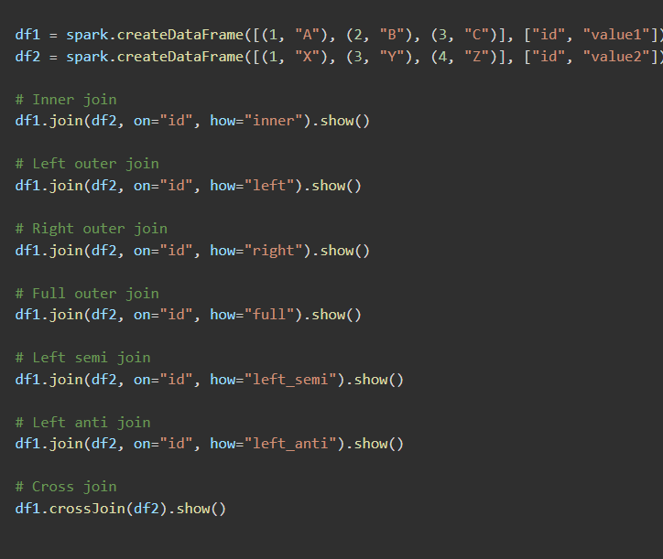

11. How does `cache()` differ from `persist()` in PySpark?

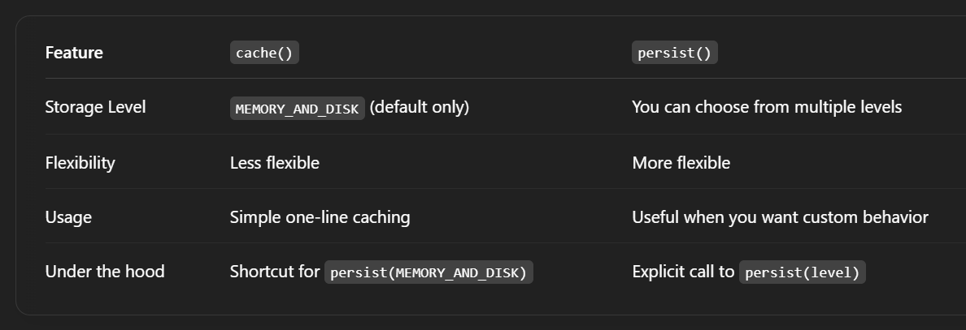

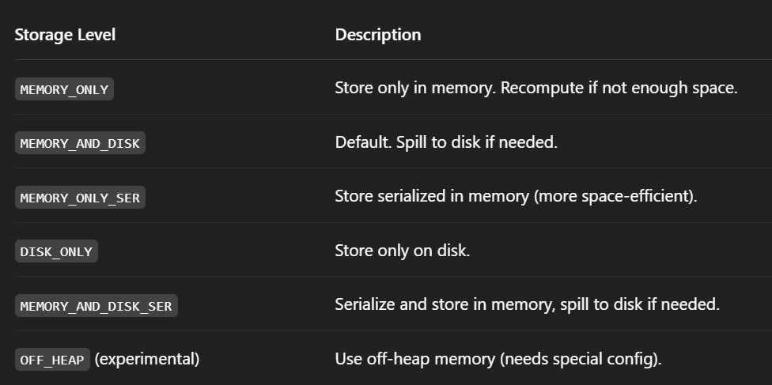

12. What is the significance of `broadcast` in Spark?

The **broadcast()** function in Spark allows you to **broadcast small datasets** (i.e., data that can fit into memory) to all the nodes in the cluster. This is particularly useful when one of the datasets in a join operation is small and you want to **avoid shuffling** that data.

When you broadcast a dataset, Spark sends it to each worker node, and each node keeps a **local copy** of that dataset. This eliminates the need for **data shuffling** between nodes during operations like **joins**, leading to a significant performance boost.

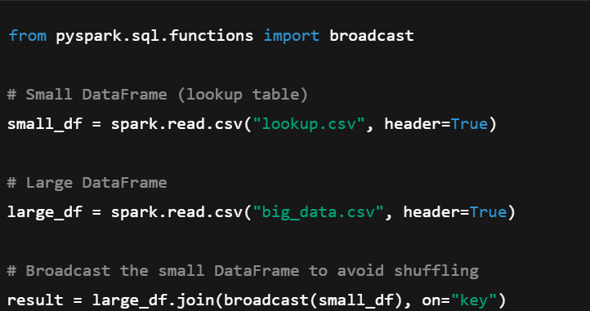

13. How do you optimize Spark jobs for performance?

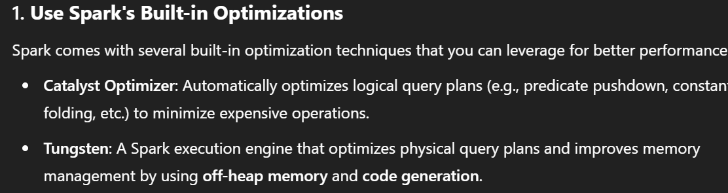

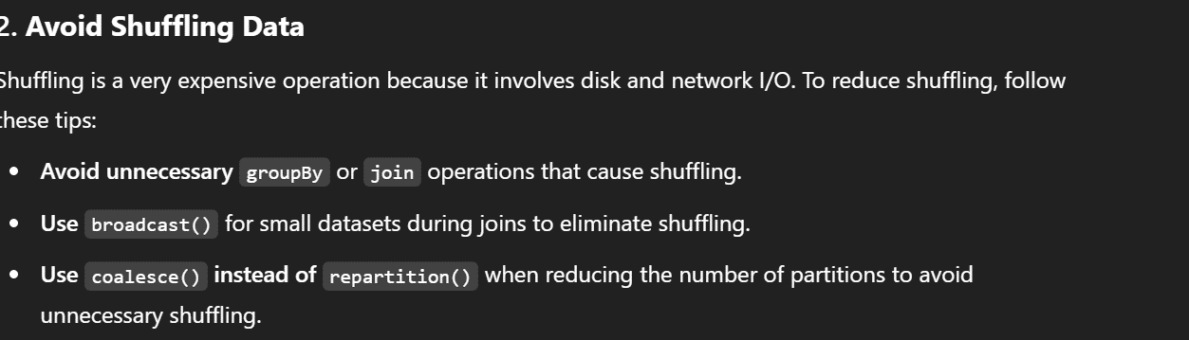

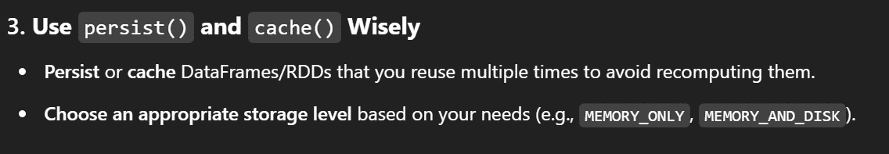

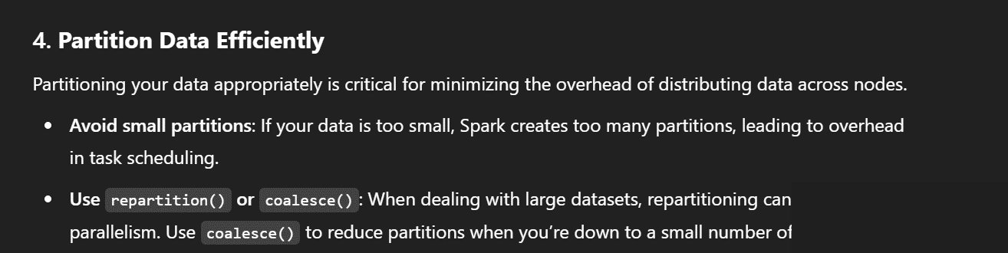

14. What are the benefits of partitioning in PySpark?

Partitioning is how Spark **divides your data** into smaller, manageable chunks across the **worker nodes** in a cluster.

Each partition is processed in **parallel**, which allows Spark to **distribute the workload** and **maximize resource usage**.

**1. Improved Parallelism & Speed**

* Spark processes **each partition in parallel** across its worker nodes.
* More partitions = more concurrent tasks = faster execution (up to a point).

📌 Example: 1 billion rows split into 100 partitions will finish faster than 10 big partitions.

**2. Reduced Data Shuffling**

* **Smart partitioning** (e.g., by join keys or grouping columns) minimizes data movement (a.k.a. shuffle) across the network during joins and aggregations.

📉 Less shuffle = faster jobs & less cluster strain.

**3. Efficient Joins and Aggregations**

* If both datasets are **partitioned by the same key**, Spark can **co-locate data**, eliminating the need to reshuffle.

🚀 This leads to **more efficient joins** and **groupBy** operations.

**4. Better Memory Utilization**

* Proper partition sizes prevent memory overload.
* Spark won’t try to load massive data chunks into memory in a single go.

📦 Smaller, well-balanced partitions = fewer out-of-memory errors.

**5. Control Over Resource Allocation**

* You can adjust partition sizes based on:
  + Number of executors
  + Size of data
  + CPU and memory per task

🛠 This gives you **fine-tuned control** over how your job uses resources.

**6. Optimized File Writing**

* When writing out data (e.g., Parquet), partitioning helps:
  + Organize the data layout (e.g., partition by date, region)
  + Speed up query performance (predicate pushdown)

📁 Partitioned files = faster reads later.

15. What is the difference between `repartition()` and `coalesce()`?

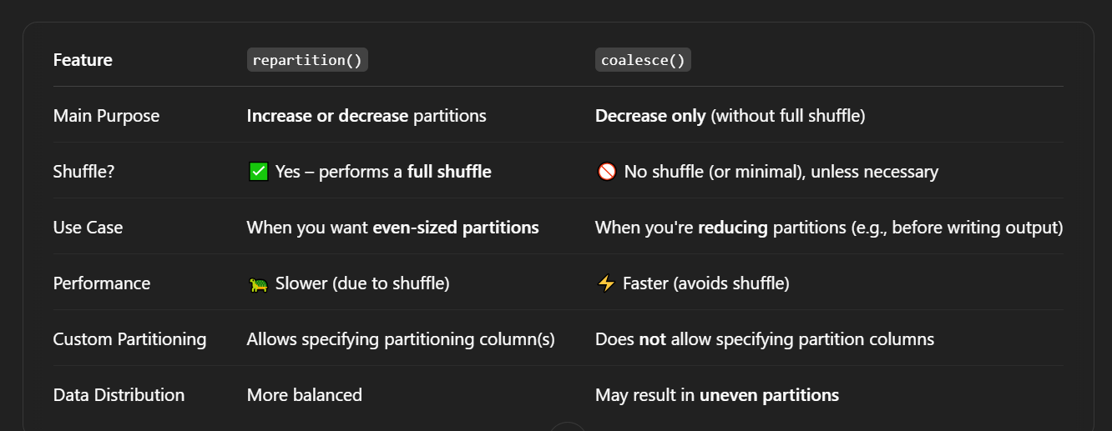

16. How do you handle skewed data in PySpark?

**1. Broadcast Join (for small table joins)**

If one table is small enough, broadcast it to all executors to **avoid shuffling** the big table.

**2. Salting Keys (for skewed join keys)**

If a **few keys are causing the skew**, add a random "salt" value to distribute them across partitions.

**Step-by-step:**

1. Add a random salt column to the large table.
2. Duplicate skewed keys in the small table with matching salt values.
3. Join on both original key and salt.

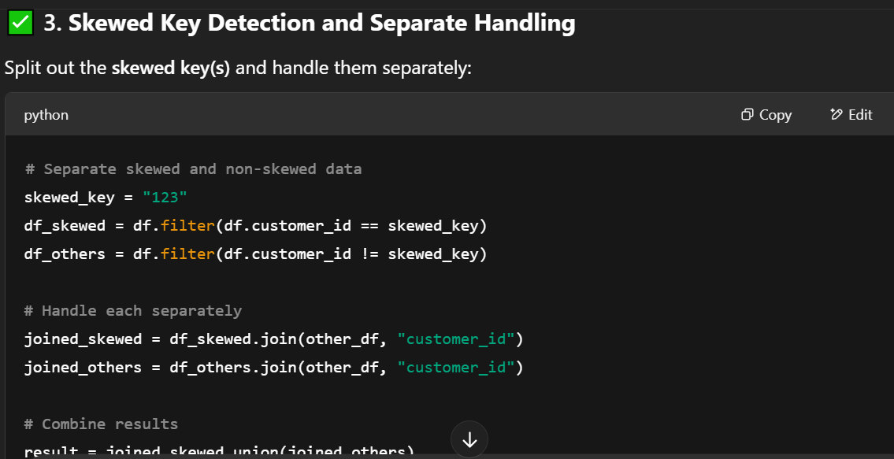

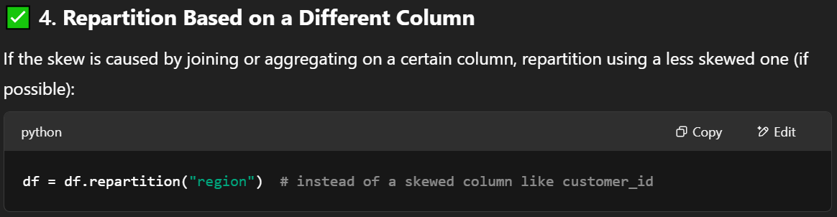

16.How does Spark execute operations in a lazy manner?

**1. You apply transformations**

* filter, select, withColumn, join, etc.
* These are just **instructions**; Spark builds a **Directed Acyclic Graph (DAG)**.

**2. Spark builds a logical plan**

* Spark records **what** you want to do, **not how**.

**3. You trigger an action**

* Examples: show(), collect(), write(), count()
* This is the moment Spark **figures out the execution plan**, **optimizes** it, and **runs the job**.

**4. Spark applies optimizations**

* **Catalyst Optimizer** rewrites your query plan (e.g., predicate pushdown, reordering filters).
* Spark then creates a **physical plan** and **executes it in stages** across the cluster.

17. How do you optimize join operations in PySpark?

**1. Use broadcast() for small tables**

If one of your tables is **small enough to fit in memory**, Spark can send it to all executors.

2. **Select only necessary columns before joining(Column Pruning)**

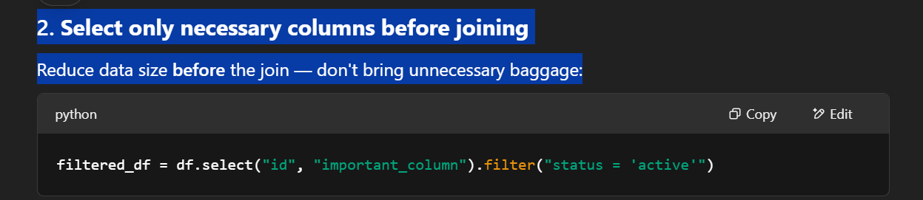

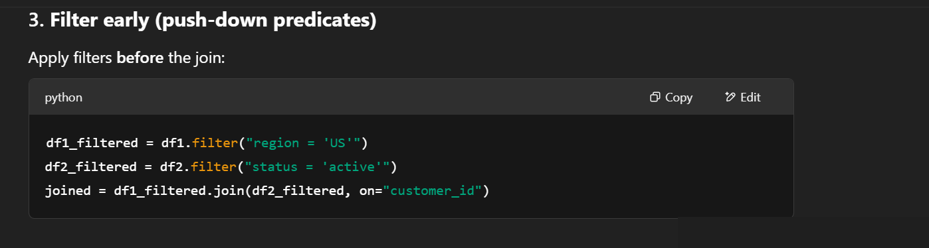

**5. Avoid wide joins when possible**

If you can do multiple **narrow joins** (e.g., join small tables first), it’s better than one large, wide join with many columns.

**6. Handle skewed data explicitly**

If certain keys are very frequent (like customer_id = 9999), Spark will struggle.

Fix with:

* **Salting**
* **Broadcasting the small side**
* **Separating skewed keys**

**7. Use appropriate join type**

* Use inner instead of outer or full joins when possible — they're **less expensive**.

18. What is Adaptive Query Execution (AQE) in Spark?

**AQE** is a feature in Spark (enabled by default from Spark 3.0+) that allows Spark to **adjust and optimize the query execution plan dynamically at runtime**, based on real data characteristics.

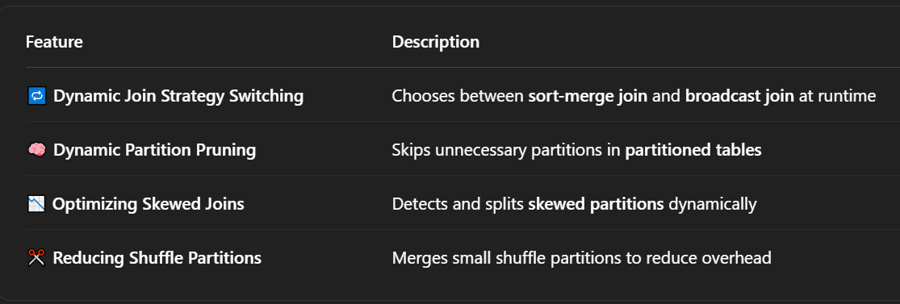

19. Write a PySpark program to find the top 3 most occurring words in a given dataset.

How do you perform word count using PySpark?

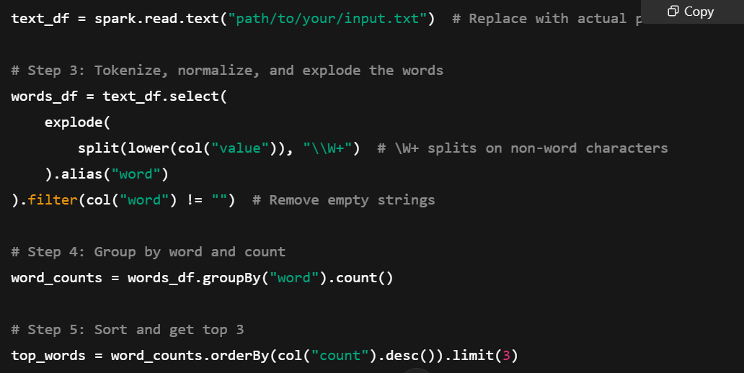

20. Given a DataFrame, write a PySpark code to remove duplicate records.



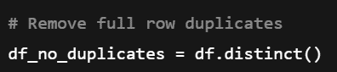

21. Write a PySpark job to group by a column and calculate the average value.

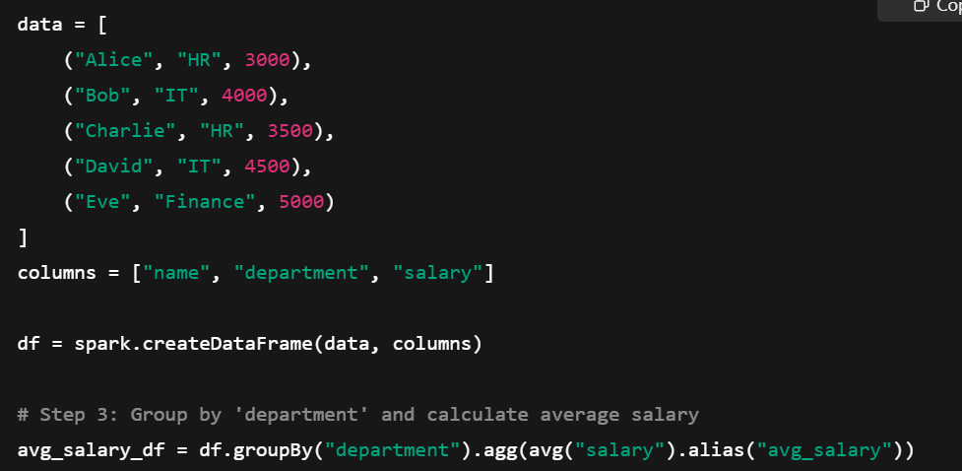

22. How do you handle missing/null values in a PySpark DataFrame?

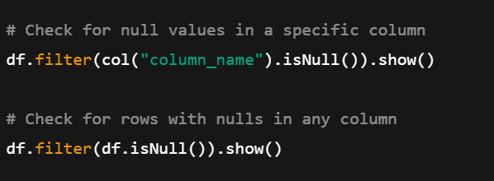

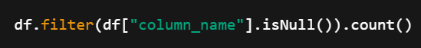





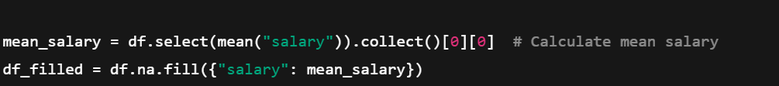

23. Write a PySpark program to count distinct values in a column.



24. Given a DataFrame, write a PySpark code to filter records where salary > 50,000.



25. Write a PySpark job to read a JSON file and convert it into a DataFrame.

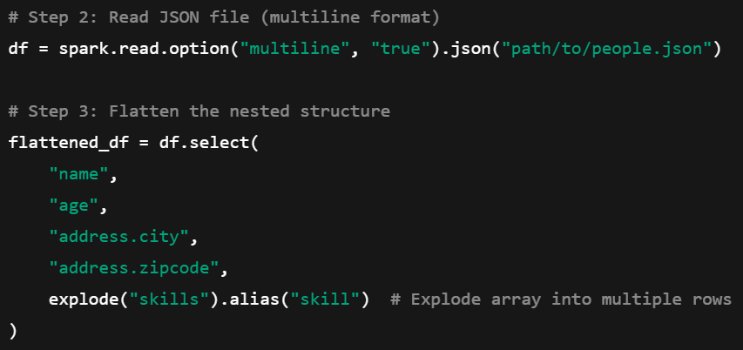

26. Write a PySpark query to find the second highest salary from an employee table.

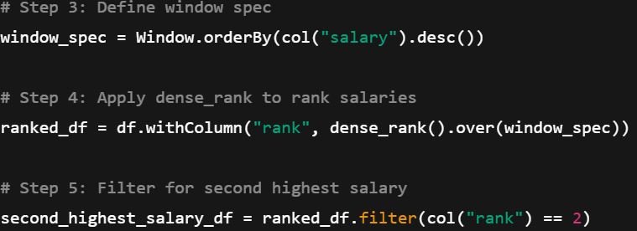

27. Write a PySpark job to join two DataFrames and select specific columns.

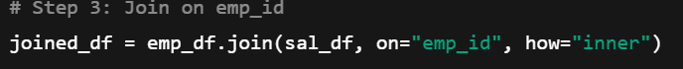

28. How do you create a temporary view in PySpark?

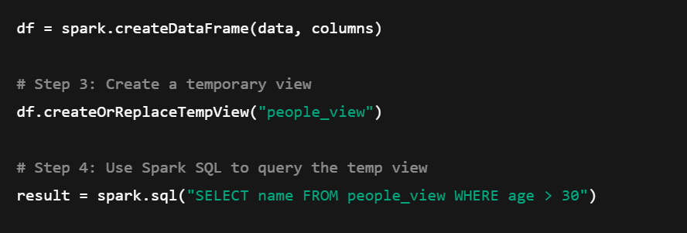

29. What is the difference between `df.select()` and `df.withColumn()`?

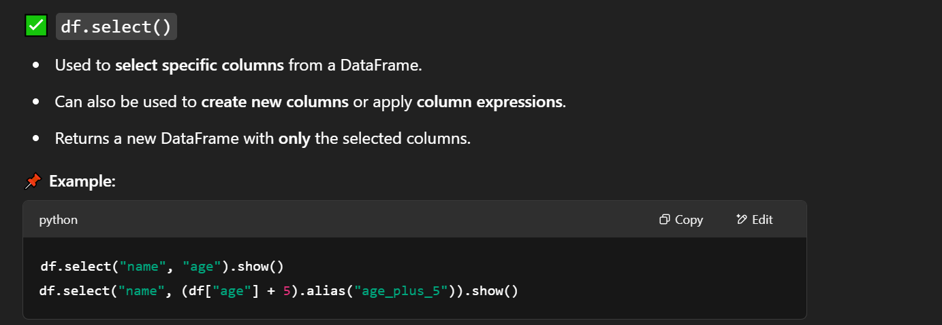

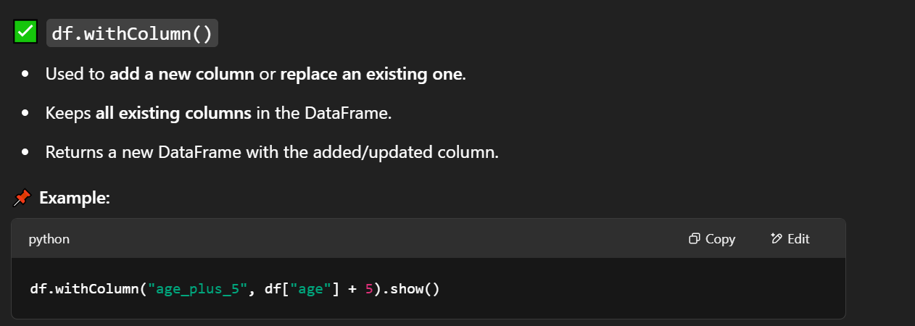

30. How do you write and execute SQL queries in PySpark?



31. What is the difference between `explode()` and `posexplode()`?

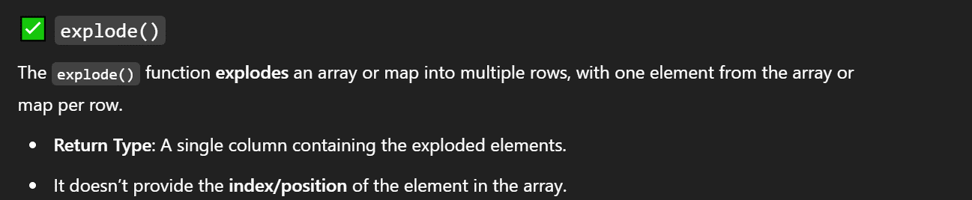

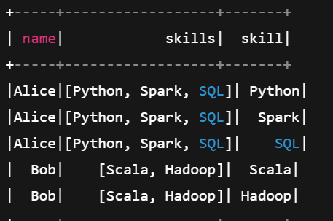

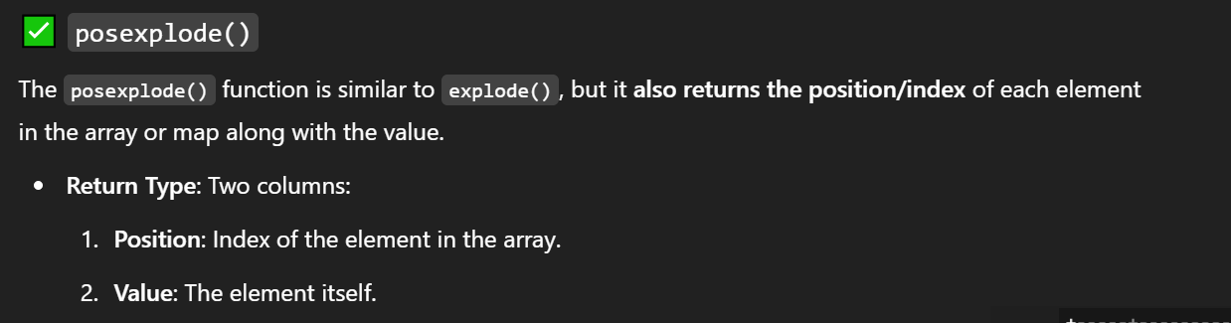

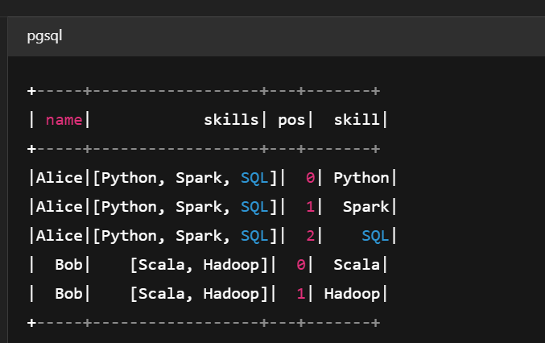

32. How do you convert a DataFrame into a SQL table?







33. How do you use window functions in PySpark?





34. Write a PySpark SQL query to get the cumulative sum of a column.

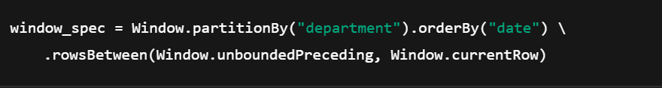



35. What is the difference between `groupBy()` and `rollup()`?

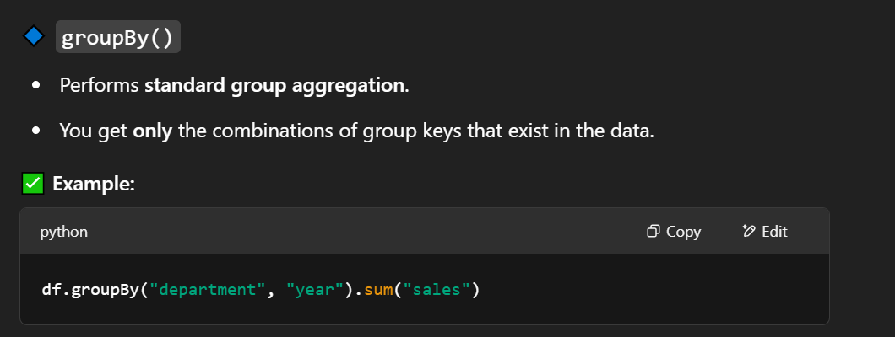

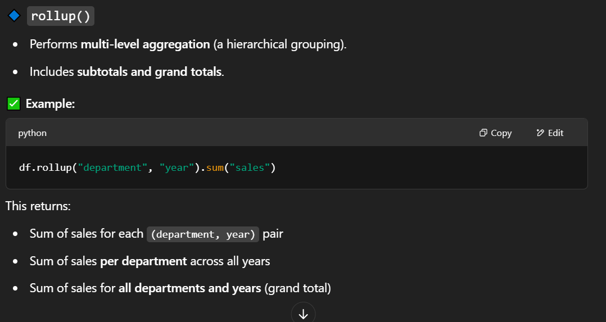

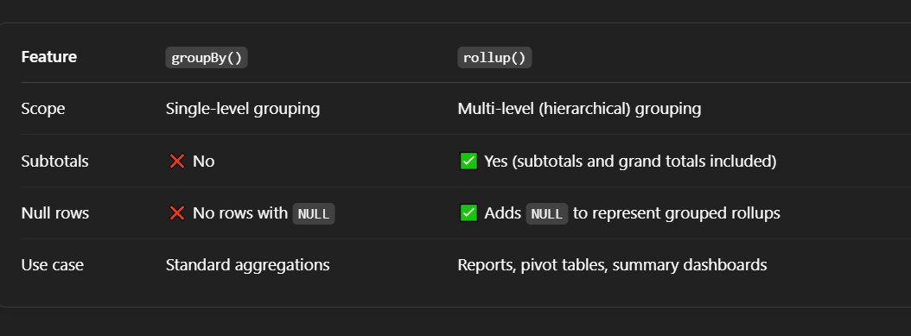

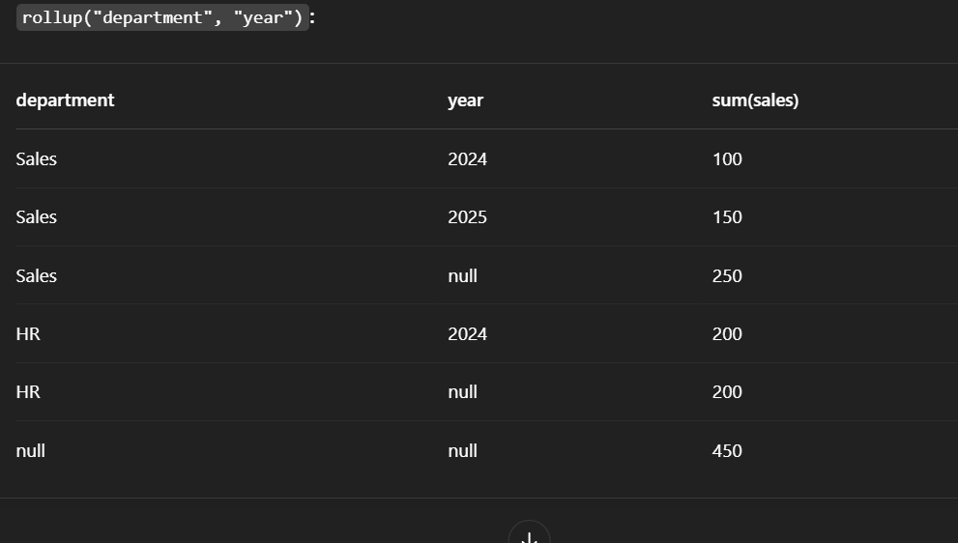

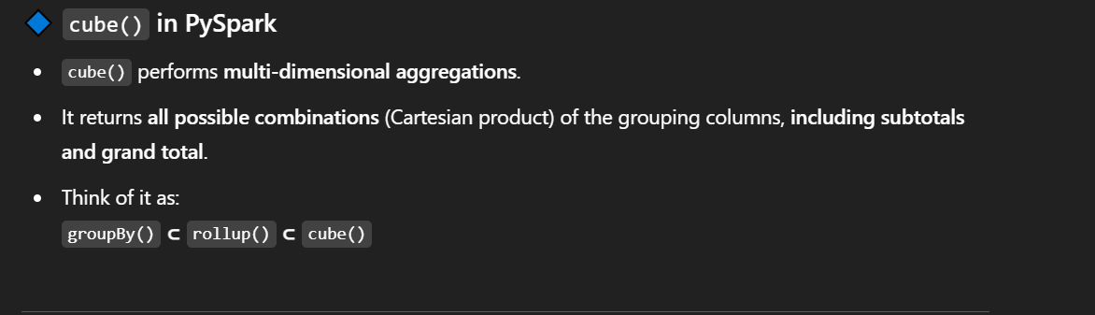

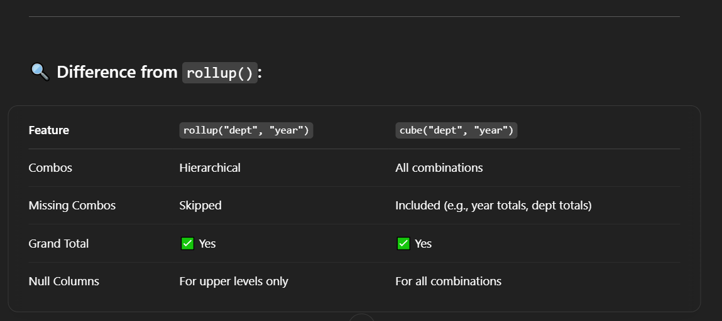

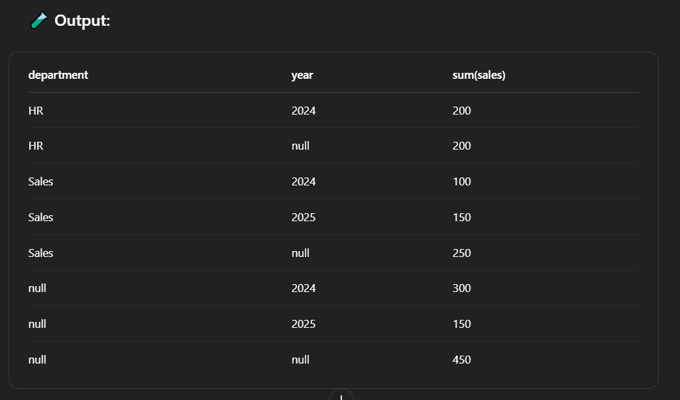

36. How do you perform pivot operations in PySpark?

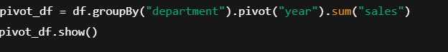

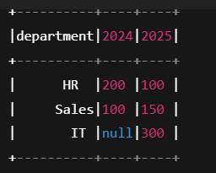

PySpark doesn’t have a built-in melt() function like Pandas, but you can **simulate unpivoting** using selectExpr + stack() if needed.

37. What is Spark Streaming, and how does it work?

**Spark Streaming** is a component of **Apache Spark** that enables **real-time processing** of data streams. It allows you to process live data from sources like Kafka, Flume, Kinesis, or sockets and perform transformations and actions just like batch jobs.

Spark Streaming works by:

1. **Dividing** the incoming data stream into small **batches** (micro-batching).
2. Each batch is processed using the **Spark engine** (like a mini Spark job).
3. The results are returned in near-real-time

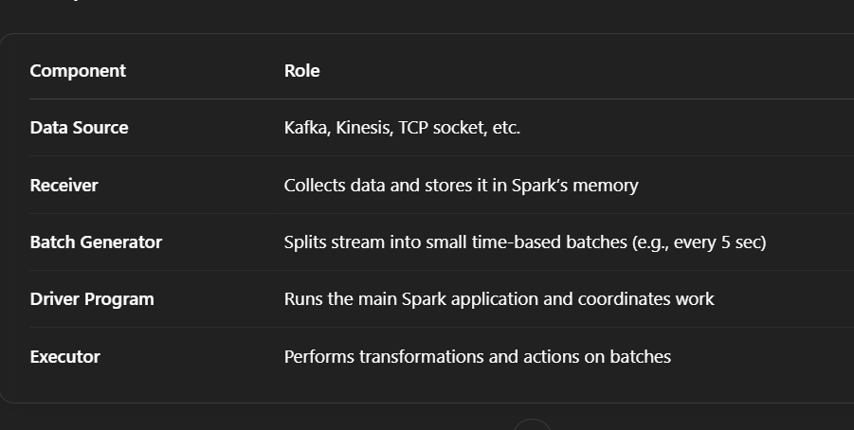

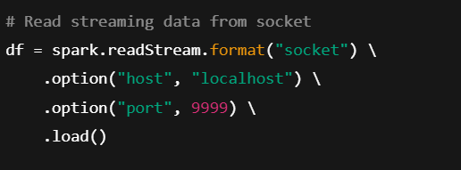

38. What is the difference between structured and unstructured streaming?

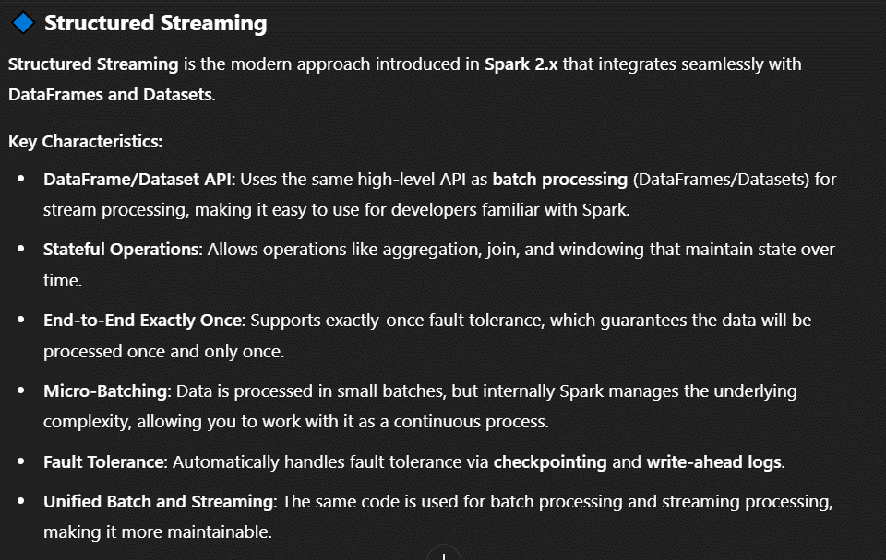

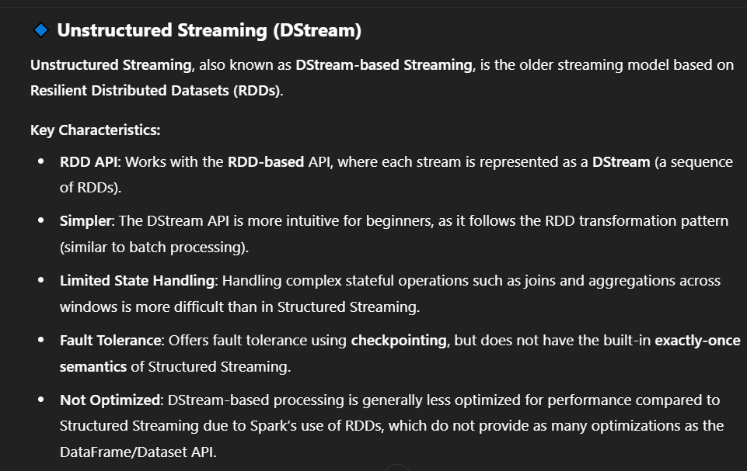

39.How do you handle late-arriving data in Spark Streaming?

**Watermarking** is a technique in **Structured Streaming** used to track the **progress** of event time and allow late-arriving data to be processed even after the expected time window has passed. When data is processed by **event time** (e.g., timestamps in the data), late data that arrives after the window has been processed is typically dropped. Watermarking allows Spark to **delay processing** by a specified duration to accommodate late data.

* **Watermark Definition**: You define a watermark to indicate how much "lateness" you are willing to accept for each event time.
* **How It Works**: Spark will retain state for windows of data that are within the watermark threshold, and it will process late data that falls within the allowed window.

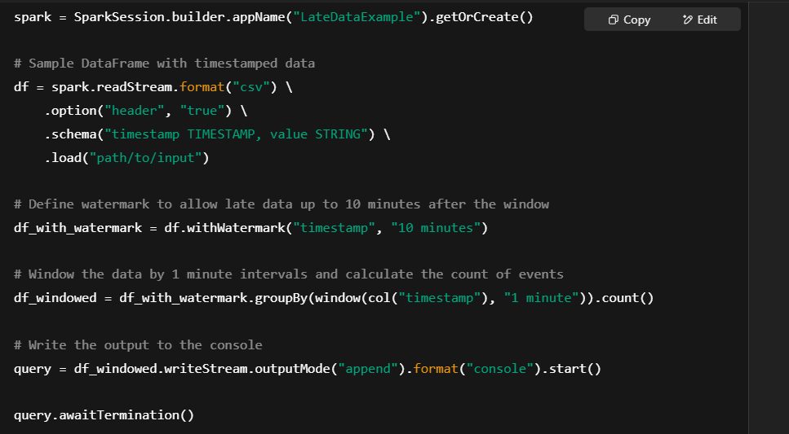

**Watermark Explained**: In the above example, withWatermark("timestamp", "10 minutes") tells Spark to allow late data to be processed for up to **10 minutes** after the window time.

**When to Use**: Use watermarking when you are working with **event-time** data (like logs or sensor data) and expect that some events may arrive out of order but you still want to process them correctly.

**2️ Allowed Lateness**

In **Structured Streaming**, **allowed lateness** is the period during which late data can still be included in the result of a windowed operation. It works in conjunction with watermarks.

* **How It Works**: Allowed lateness ensures that the processing of late-arriving data is done even after the window has been closed.
* **Effect**: If you specify an allowed lateness period, Spark will allow late data to be added to a previously closed window until the allowed lateness period has passed.

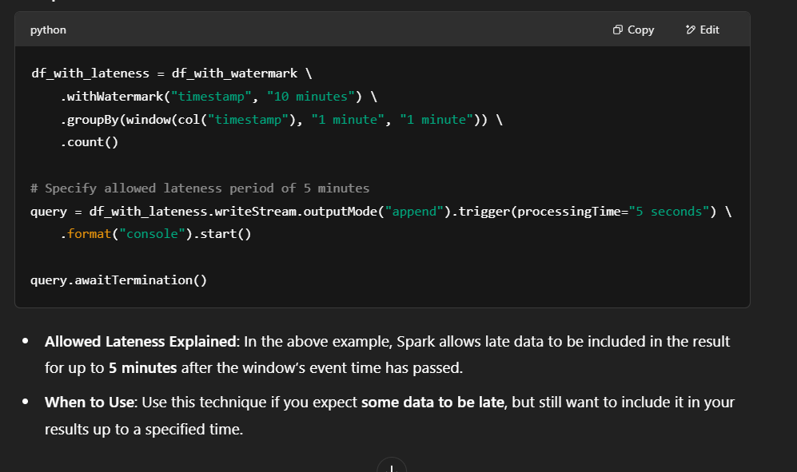

40. Describe the role of the Catalyst optimizer in PySpark. How does it enhance query execution?

Catalyst is a **query optimization framework** used in **Spark SQL and Structured Streaming**. It takes user-written queries (in SQL or DataFrame API) and **optimizes them through multiple stages**, resulting in **high-performance execution plans**.

**1. Logical Plan Optimization**

* It starts with a **logical plan** (based on what the user writes using DataFrame or SQL).
* Catalyst applies **rule-based optimizations** like:
  + Constant folding
  + Boolean expression simplification
  + Predicate pushdown
  + Null propagation

**2. Physical Plan Generation**

* Converts the optimized logical plan into one or more **physical plans**.
* Evaluates **different strategies** (e.g., hash join, sort merge join) and selects the most efficient one using **cost-based optimization** (if enabled).

**3. Code Generation (Tungsten Project)**

* Uses **whole-stage code generation (WSCG)** to generate optimized **Java bytecode** for execution.
* Minimizes virtual function calls and object creation, improving CPU efficiency.

**4. Extensibility**

* Catalyst is highly modular and supports adding **custom rules, expressions, and strategies**, which helps advanced users fine-tune query behavior.

41. How do you create and register a user-defined function (UDF) in PySpark? What are the performance considerations?

Creating and registering a **User-Defined Function (UDF)** in PySpark allows you to apply custom Python logic to Spark DataFrames. While UDFs offer flexibility, they come with performance trade-offs, especially compared to Spark’s native functions.

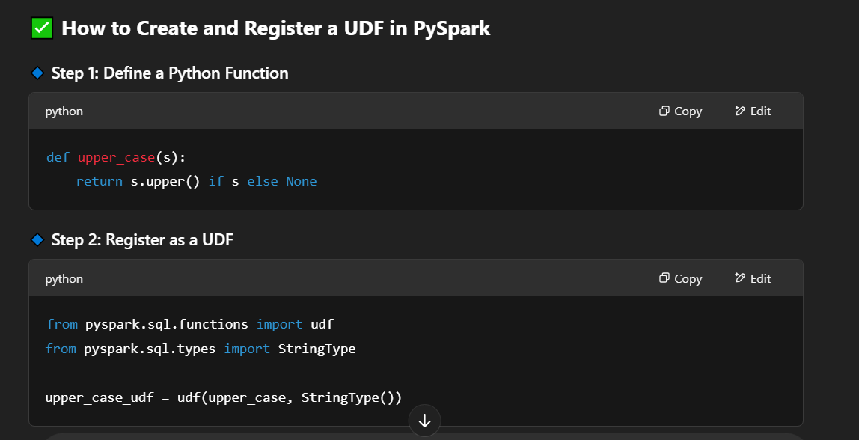

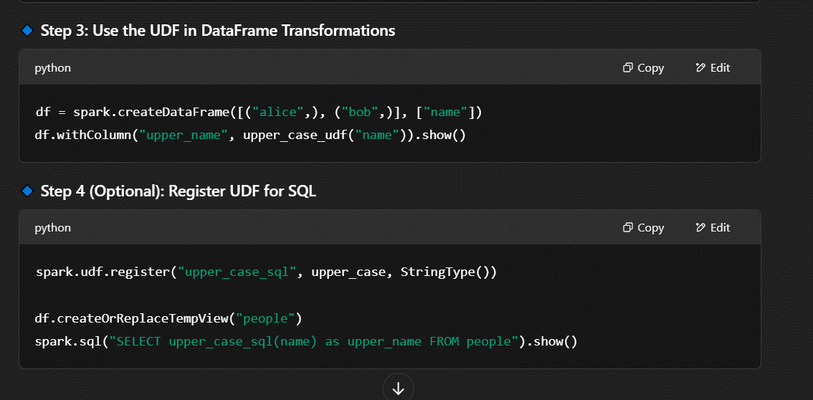

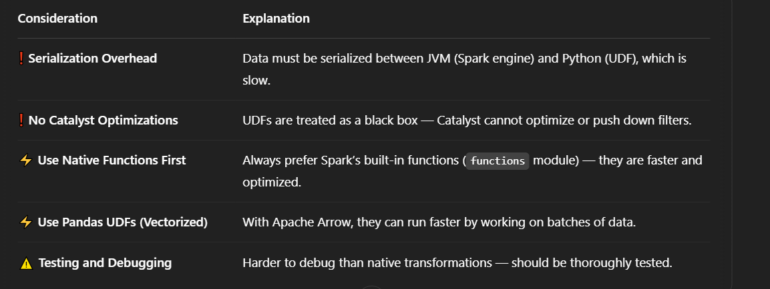

42. Discuss the concept of shuffling in PySpark. How does it affect performance, and how can it be minimized?

**Shuffling** is the process of **redistributing data** across different partitions or executors, often over the network. It happens when operations require **data from multiple partitions to be grouped or moved**, such as:

**🔹 Common operations that trigger shuffling:**

* groupBy()
* reduceByKey()
* join()
* distinct()
* repartition()
* cogroup()
* sort()

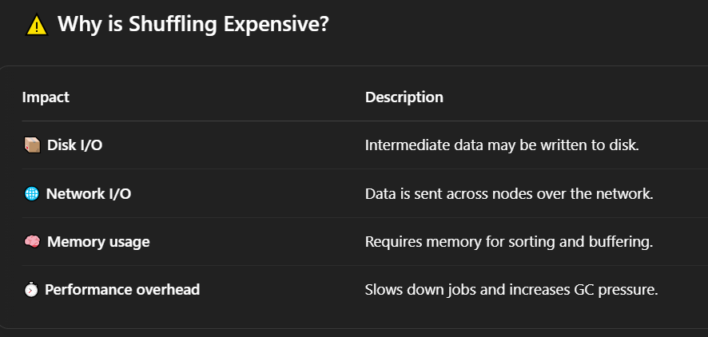

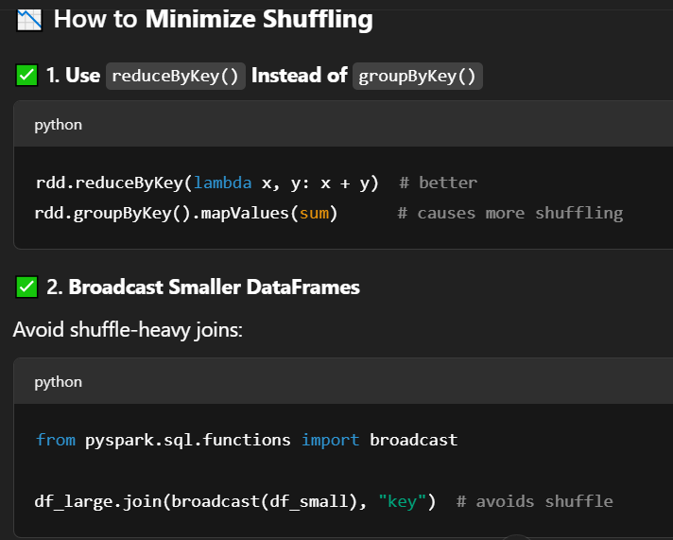

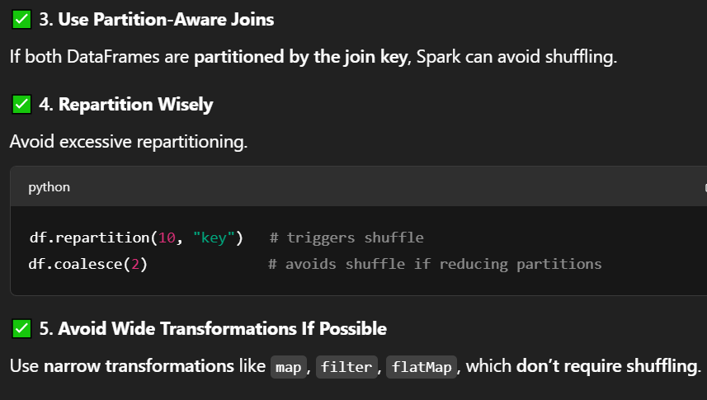

43. How do you read data from and write data to various file formats (e.g., CSV, Parquet, JSON) in PySpark?

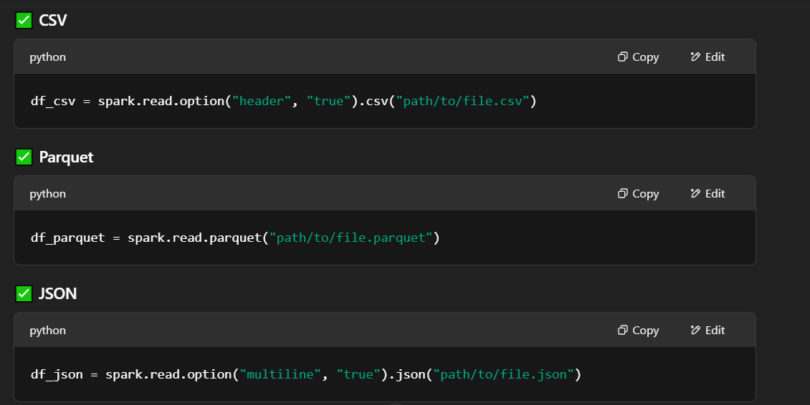

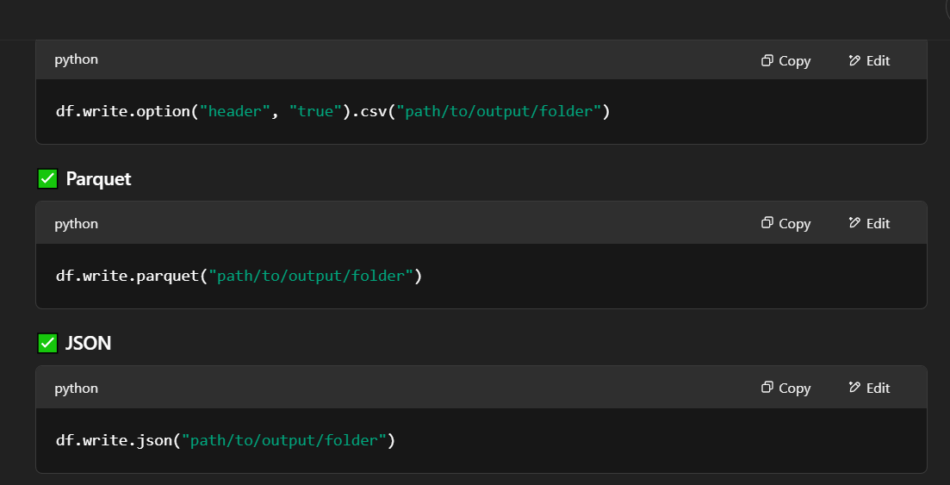

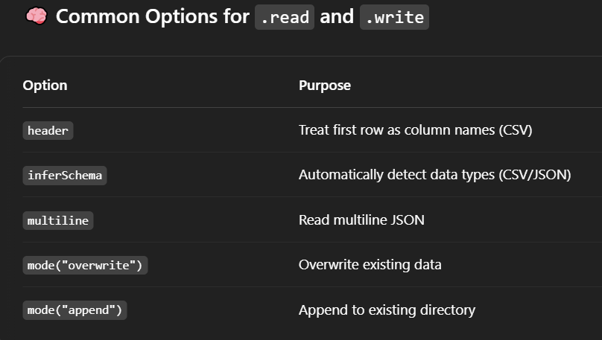

44. Calculate the top 5 products with the highest sales in each region.

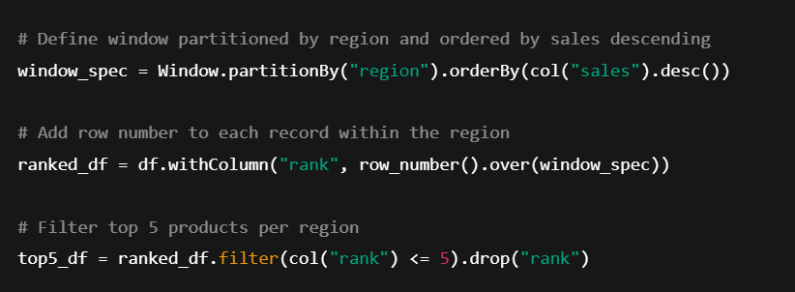

45. Join two DataFrames based on a composite key and filter rows where the sales amount exceeds a threshold.

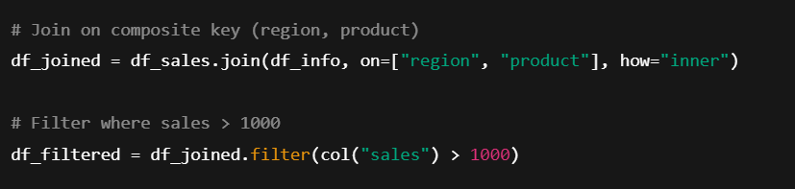

46. Calculate the running total of sales for each customer, partitioned by customer ID and ordered by date.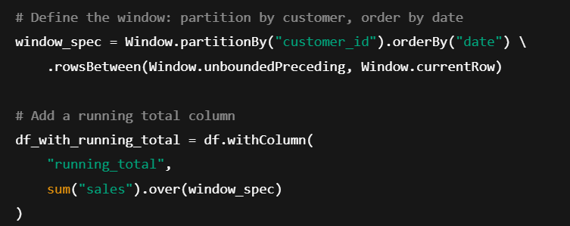

47. Implement a custom UDF to perform text sentiment analysis.

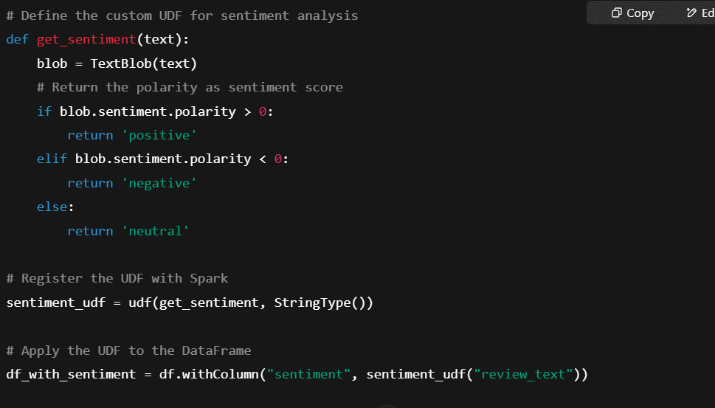

48. Identify outliers in a dataset using standard deviation or IQR methods.

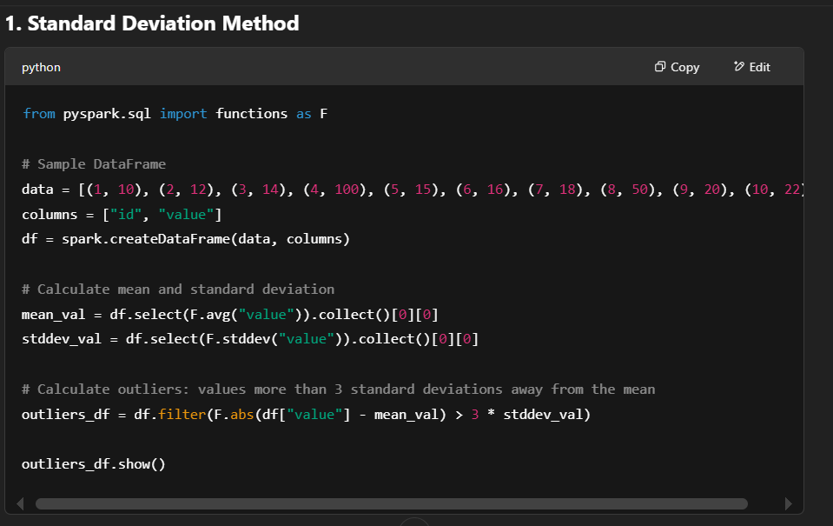

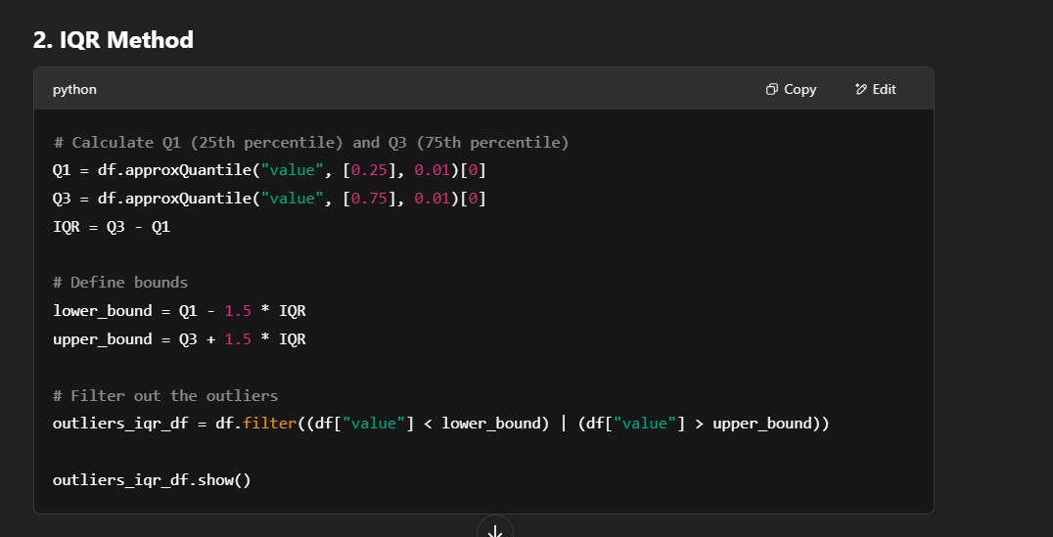

49. Perform data partitioning and bucketing for optimized query performance.

**1. Data Partitioning in PySpark**

Partitioning splits the data into different partitions based on a specified column. This can improve performance by enabling Spark to perform parallel processing on data that resides in different partitions. Partitioning is particularly useful when you often filter data by a specific column.

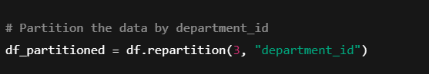

**2. Data Bucketing in PySpark**

Bucketing is a technique used to divide data into a fixed number of buckets based on the hash of a column. Unlike partitioning, which is based on the values of the column, bucketing creates a fixed number of **equal-sized** buckets, regardless of the data distribution.

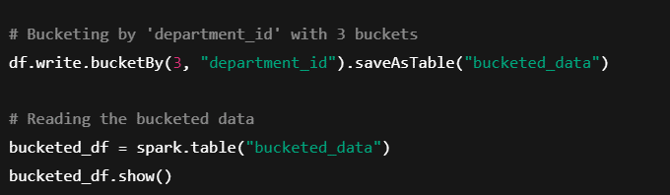

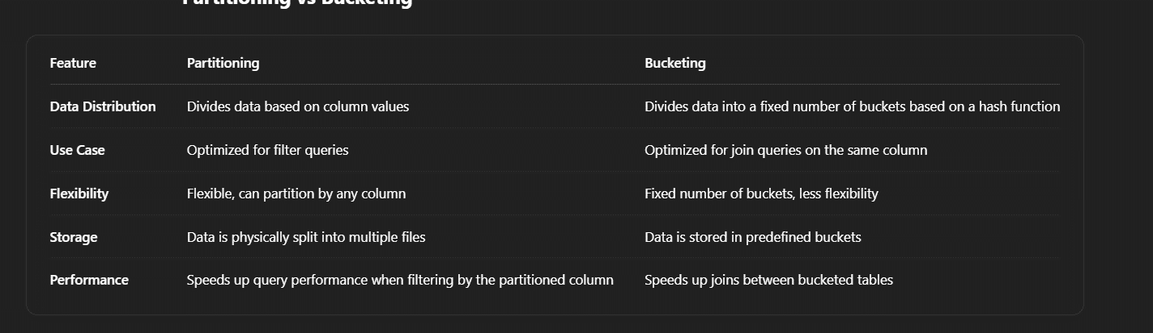

50. Use PySpark to merge multiple CSV files into a single DataFrame and remove duplicates.

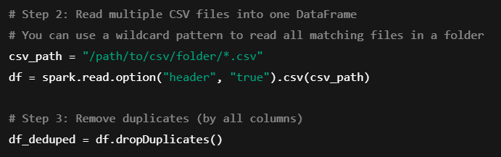

51. Convert a PySpark DataFrame to a Pandas DataFrame for advanced analytics.

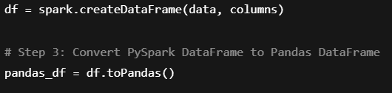

52. Write a PySpark script to stream data from Kafka and process it in real-time.

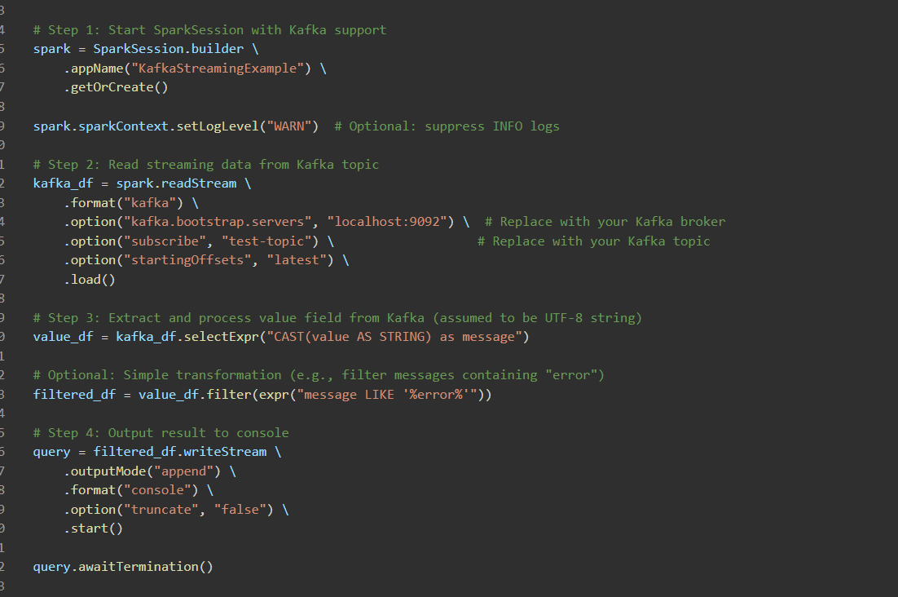

53. How would you convert a PySpark DataFrame column with a JSON string to multiple columns  
  


54. How can you remove duplicate rows in a DataFrame based on specific columns?  
  


55. how you would filter a DataFrame to include only rows where a column contains a specific substring.



56. How do you add a constant column to a PySpark DataFrame?



57. Question: How would you convert a DataFrame column from one data type to another?



58. Explain how to use a PySpark SQL query on a DataFrame.



59. How can you rename multiple columns in a PySpark DataFrame?



60. Describe how you would pivot a DataFrame in PySpark

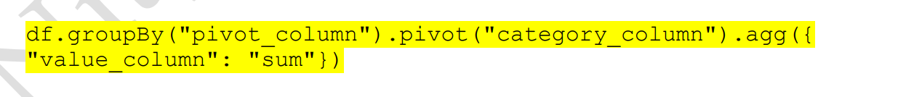

61. How can you calculate the distinct count of values in a column



62. Explain the purpose of the groupBy() and agg() function



63. How do you handle null values in a DataFrame column?



64. How would you read a CSV file into a PySpark DataFrame with a header and custom delimiter?



65 . How can you sort a DataFrame by multiple columns in ascending and descending order?



66. Describe how you would join two DataFrames on multiple keys.



67. How do you calculate the rank of rows within each partition of a DataFrame?



68. How do you perform an inner join and filter out rows with nulls in one of the columns after the join?



69. How can you change the number of partitions in a DataFrame to improve performance?



70. How would you aggregate data using both sum and average functions in a single query?



71. Explain how to concatenate two string columns with a separator.\

